Matrix Expo:
Given a graph G of k node, how many distinct path of length n are there that starts from node 1? This problem could also be solved by matrix multiplication.
Let A be a 1 x k matrix which consist of the number of path that end in each node, for the initial case of course it will be (1, 0, …, 0). Let B the adjacency matrix of graph G. If we multiply A with B, we will get a matrix C which consist of the number of path of length-1 that end in each node. If we multiply C with B again, we will get a matrix D which consist of the number of path of length-2 that end in each node, and so on.
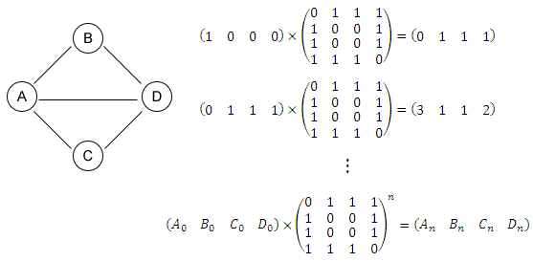
There are 3 + 1 + 1 + 2 = 7 paths of length 2 in the graph above:
A – B – A
A – C – A
A – D – A
A – D – B
A – D – C
A – B – D
A – C – D

